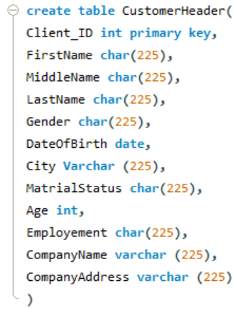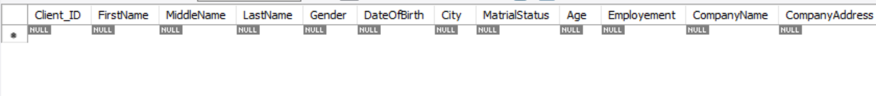

**Write a Query to Alter the column Employement (char) TO Employement(Varchar)**

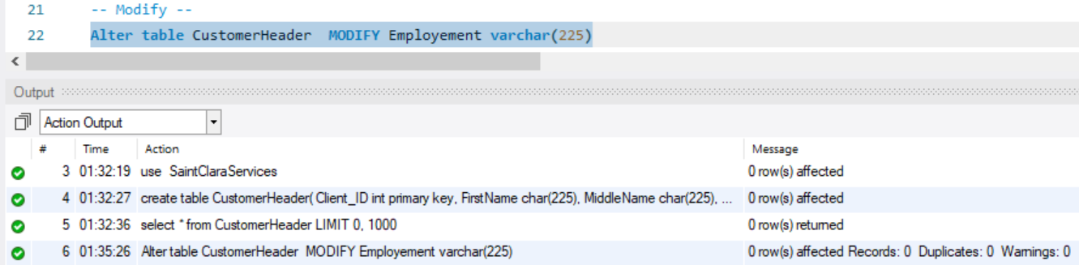

**Write a query to add a new Qualification(char) column in to CustomerHeader table**

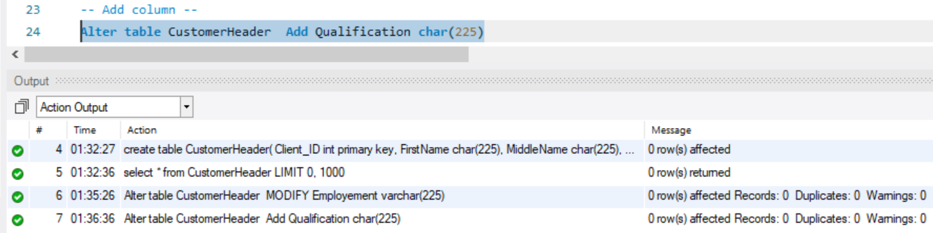

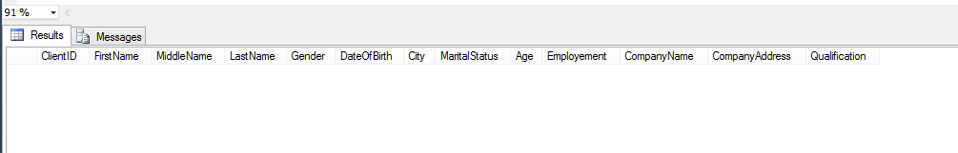

**Write a query to drop a MiddleName column from an existing CustomerHeader table**

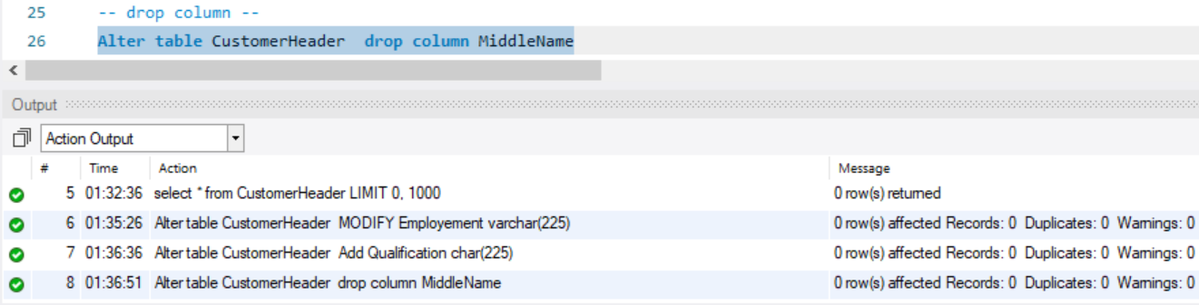

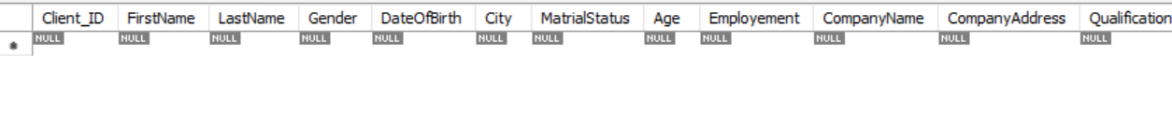

**DDL QUERIES TABLE 2**

**Create another table CustomerDetails inside the existing with the specifications given in table**

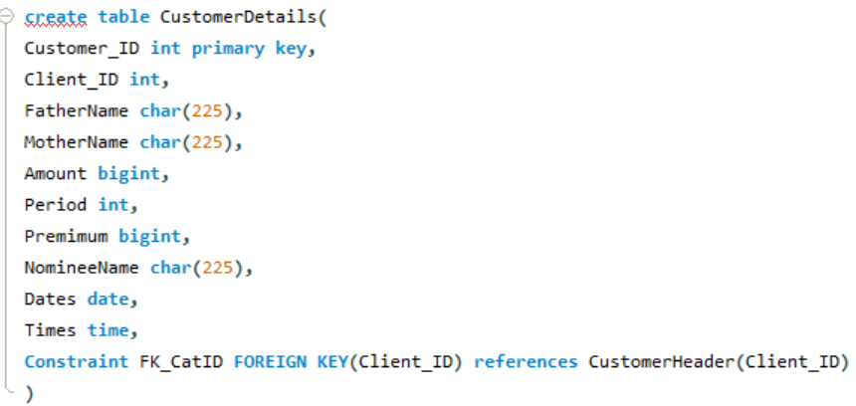

**Write a Query to Alter the column Period (int) TO Period(bigint)**

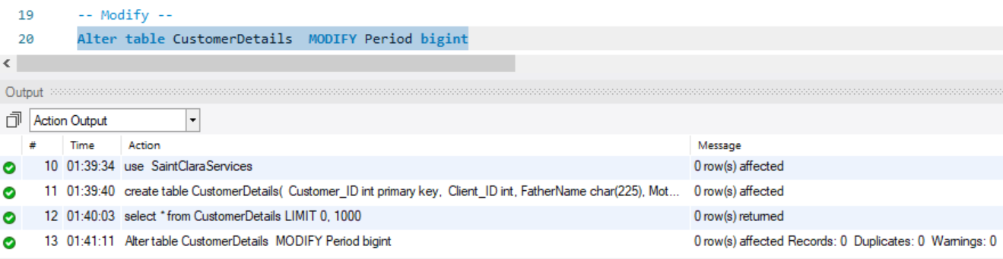

**Write a query to add a new Plan(Varchar) column in to CustomerDetails table**

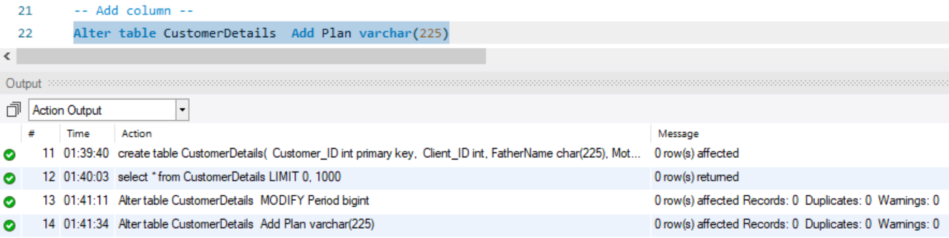

**Write a query to drop a Time column from an existing CustomerDetails table**

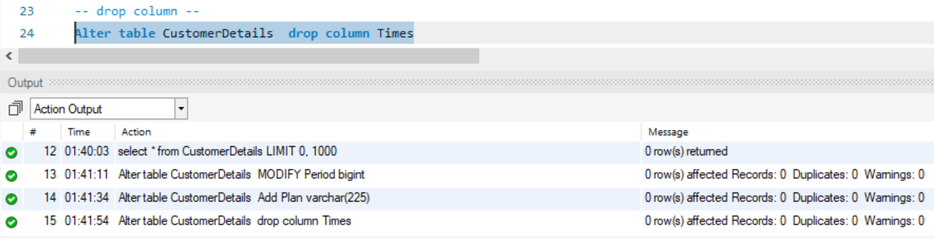

**Write a query to insert the given records in to CustomerHeader Table**

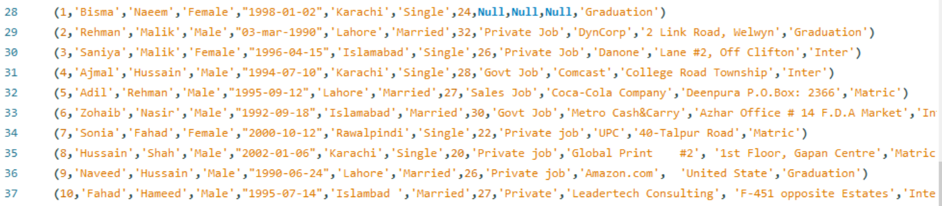

**Write a query to display all records from CustomerHeader Table**

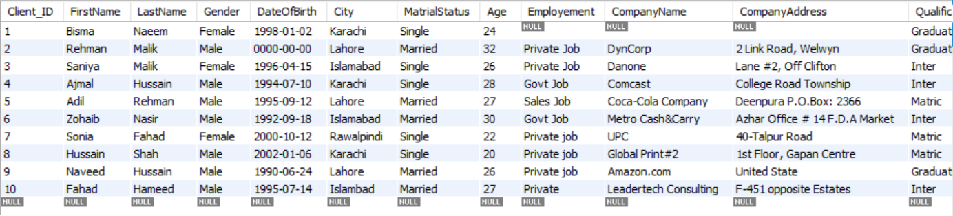

**Write a query to update the employment column value private job to Sales Job where company name is amazon.com from CustomerHeader Table**

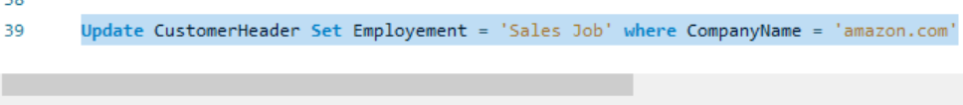

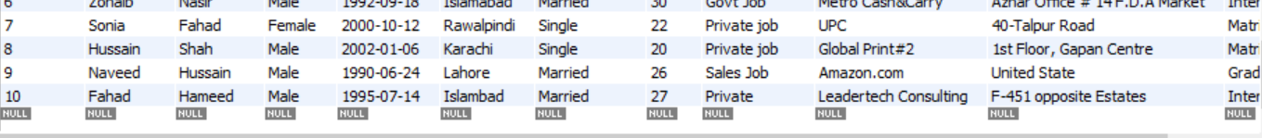

**DML QUERIES Table 2**

**Write a query to insert the given records in to CustomerDetail Table**

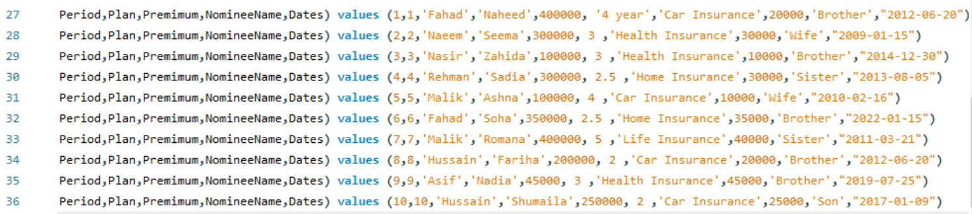

**Write a query to display all records from CustomerDetail Table**

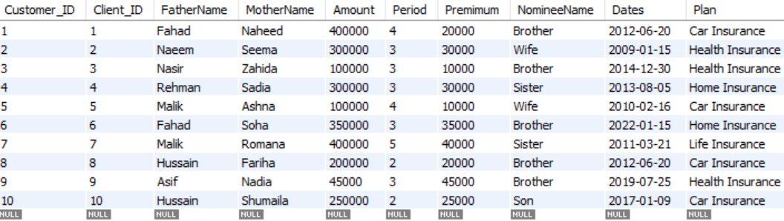

**Write a query to update the Plan column value Car Insurance to Home Insurance where company cusyomerID is 9 from CustomerHeader Table**

